Worksheet No. - 7

Student Name: Sujal Dhiman UID: 25MCA20186
Branch: MCA Section/Group: 1A
Semester: 2nd Date of Performance: 31/03/2026 Subject Name: TECHNICAL TRAINING Subject Code:25CAP-652

Aim/Overview of the practical:
To study and implement different types of SQL JOIN operations such as INNER JOIN, LEFT JOIN, RIGHT JOIN, CROSS JOIN, and multiple joins to retrieve and analyze data from related tables.
Objective:
Apply joins to a real-world database schema (e.g., Students, Courses, Enrollments, Departments)
1. Write queries to list students with their enrolled courses (INNER JOIN).
2. Find students not enrolled in any course (LEFT JOIN).
3. Display all courses with or without enrolled students (RIGHT JOIN).
4. Show students with department info using SELF JOIN or multiple joins.
5. Display all possible student-course combinations (CROSS JOIN). (Oracle, SAP, IBM, Microsoft)

Input/Apparatus Used:
- Oracle
- MS SSMS
- PostgreSQL
Procedure/Algorithm/Code :
CREATE TABLE Students (
student_id INT PRIMARY KEY,
student_name VARCHAR(50),
dept_id INT
);

CREATE TABLE Courses (
course_id INT PRIMARY KEY,
course_name VARCHAR(50)
);

CREATE TABLE Enrollments (
student_id INT,
course_id INT,
PRIMARY KEY (student_id, course_id)
);

CREATE TABLE Departments (
dept_id INT PRIMARY KEY,
dept_name VARCHAR(50)
);

INSERT INTO Students VALUES (1, 'Amit', 10);
INSERT INTO Students VALUES (2, 'Riya', 20);
INSERT INTO Students VALUES (3, 'John', 10);
INSERT INTO Students VALUES (4, 'Sara', 30);

INSERT INTO Courses VALUES (101, 'Math');
INSERT INTO Courses VALUES (102, 'Science');
INSERT INTO Courses VALUES (103, 'Computer');

INSERT INTO Enrollments VALUES (1, 101);
INSERT INTO Enrollments VALUES (1, 102);
INSERT INTO Enrollments VALUES (2, 103);

INSERT INTO Departments VALUES (10, 'Engineering');
INSERT INTO Departments VALUES (20, 'Medical');
INSERT INTO Departments VALUES (30, 'Arts');

-- 1 part (INNER JOIN)
SELECT s.student_name, c.course_name
FROM Students s
INNER JOIN Enrollments e ON s.student_id = e.student_id
INNER JOIN Courses c ON e.course_id = c.course_id;

-- 2 part (LEFT JOIN)
SELECT s.student_name
FROM Students s
LEFT JOIN Enrollments e ON s.student_id = e.student_id
WHERE e.course_id IS NULL;

-- 3 part (RIGHT JOIN)
SELECT c.course_name, s.student_name
FROM Students s
RIGHT JOIN Enrollments e ON s.student_id = e.student_id
RIGHT JOIN Courses c ON e.course_id = c.course_id;

-- 4 part (MULTIPLE JOINS)
SELECT s.student_name, d.dept_name
FROM Students s
INNER JOIN Departments d ON s.dept_id = d.dept_id;

-- 5 part (CROSS JOIN)
SELECT s.student_name, c.course_name
FROM Students s
CROSS JOIN Courses c;

Output:

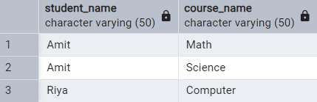
- Inner Join

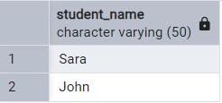
- Left Join
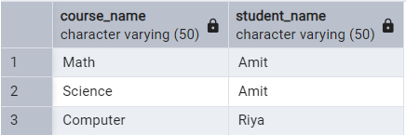
- Right Join

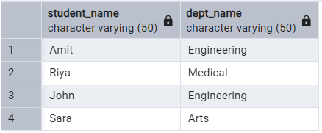
- Multiple Joins
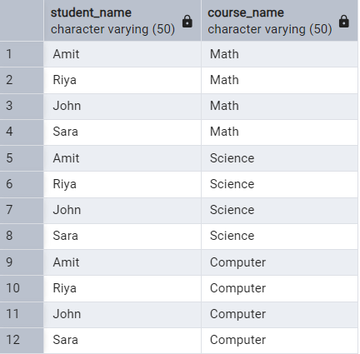
- Cross Join

Learning outcomes (What I have learnt):
- Understand the concept of relational databases and table relationships.
- Apply different types of SQL JOINs such as INNER JOIN, LEFT JOIN, RIGHT JOIN, and CROSS JOIN.
- Retrieve meaningful data by combining multiple tables using JOIN operations.
- Identify differences between various JOIN types and their use cases.
- Execute queries to find matched and unmatched records from tables.

